Testing - Performance and Load Testing (JMeter)
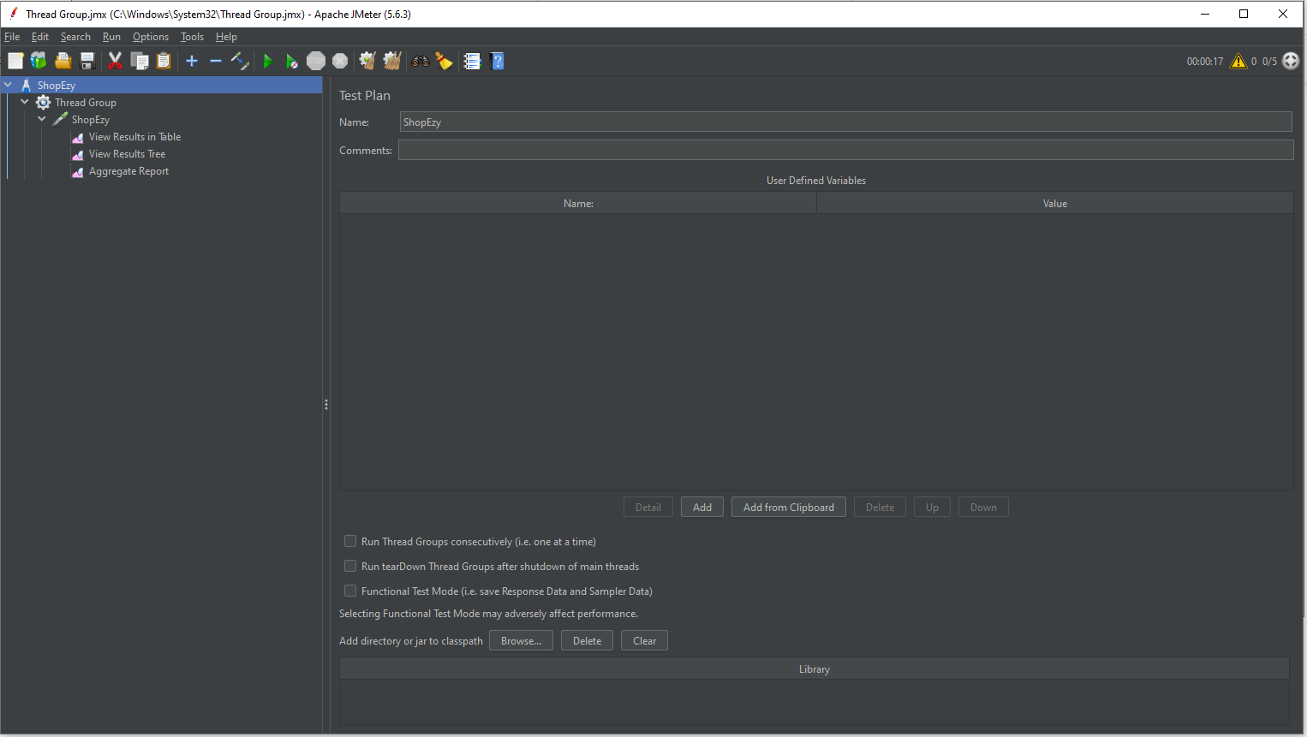
Figure 1
The picture is a screen grab of the Apache JMeter program, with the test plan configuration in particular displayed. As can be seen in the title bar, the test plan is called "ShopEzy" and is a component of a project called "Thread Group.jmx." A "Thread Group" is set up with various components for results reporting on the left pane, including "View Results in Table," "View Results in Tree," and "Aggregate Report." The test plan settings are shown in the main pane, where the word "ShopEzy" is shown next to an empty remark box and a section labelled "User Defined Variables," which presently has nothing in it. At the bottom, there are numerous options linked to the execution of the thread group, including checkboxes to run thread groups consecutively or in "Functional Test Mode," yet none are chosen now. Moreover, buttons for managing libraries are there. In addition to warning icons that might point to configuration or performance concerns, the status bar in the top-right corner indicates that the test has been running for 17 seconds and offers access to several options including storing or starting tests. This interface is a component of the JMeter performance test plan's initial setup.
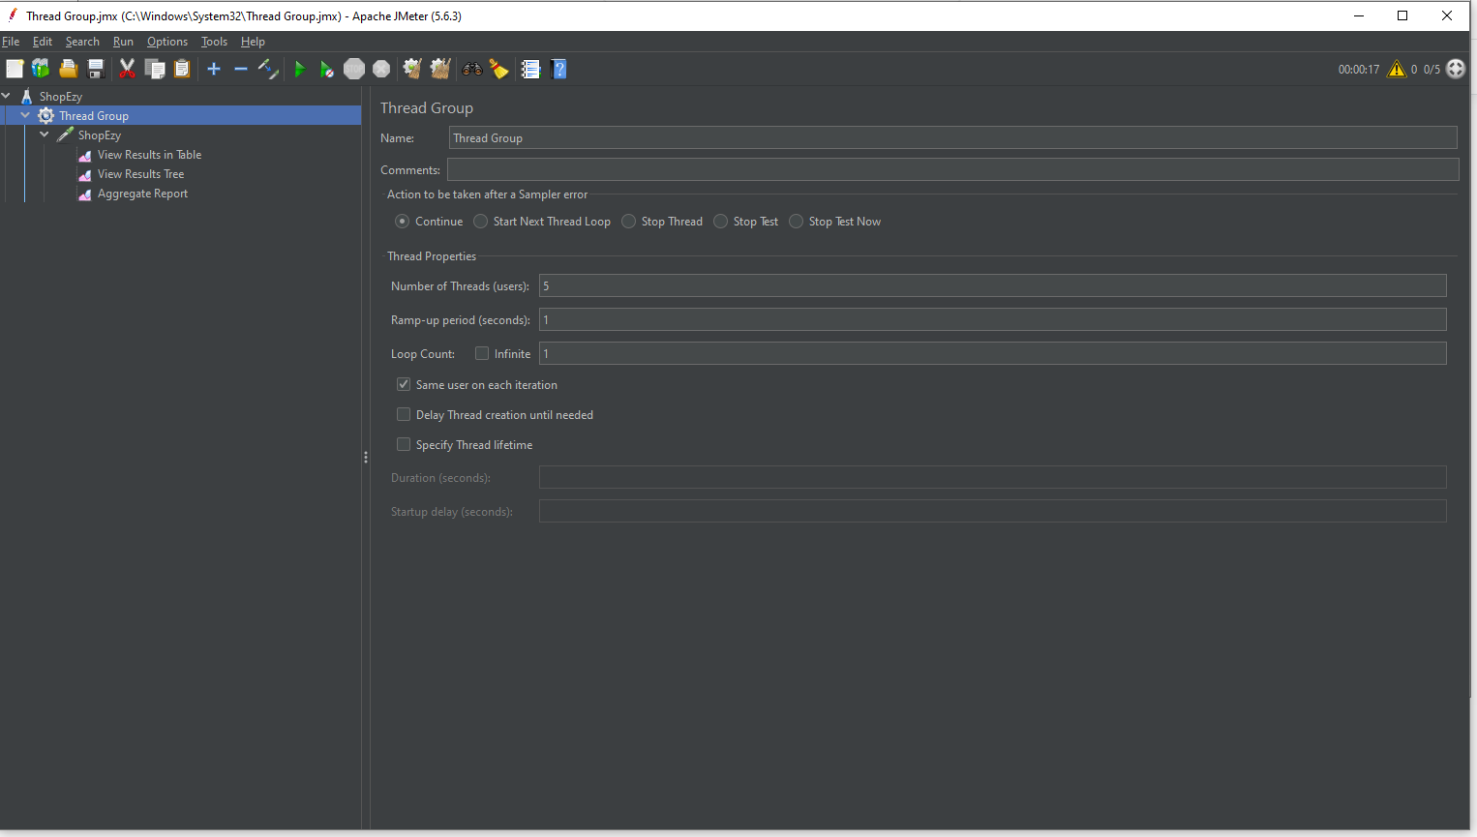
Figure 2
The image is another screenshot of the Apache JMeter application, specifically showing the configuration settings for a "Thread Group" within the "ShopEzy" test plan. The thread group configuration panel is displayed in the main area, where the group is named "Thread Group," and there is an empty comment section. Under the "Action to be taken after a Sampler error" section, several radio buttons are available to choose what should happen when an error occurs: continue, start next thread loop, stop thread, stop test, or stop test now. None of these options appear to be selected.
The user can provide important properties like the following in the "Thread Properties" section:
- The value of "Number of Threads (users)" is 5.
- The amount of time needed to start all threads is indicated by the "Ramp-up period (seconds)" setting, which is set to 1.
- With "Loop Count" set to unlimited, the test will never stop unless it is manually terminated.
A "Scheduler" checkbox and further parameters like "Duration" and "Startup delay," which are either deactivated or not specified at this time, are included in the list of options.
The thread group "ShopEzy" has been enlarged to display result options such as "View Results in Table," "View Results in Tree," and "Aggregate Report." The left pane displays the same test plan hierarchy. The test can be started, stopped, or saved using the same toolbar at the top. The test has been running for 17 seconds, as indicated by the status bar in the upper-right corner. There are warning icons, which point to configuration or performance problems. The thorough configuration of a thread group, which regulates user and thread behaviour during JMeter performance testing, is shown in this screenshot. Additional choices consist of a "Scheduler" checkbox as well as additional settings like "Duration" and "Startup delay," which are either unset or disabled now.

The thread group "ShopEzy" has been enlarged to display result options such as "View Results in Table," "View Results in Tree," and "Aggregate Report." The left pane displays the same test plan hierarchy. The test can be started, stopped, or saved using the same toolbar at the top. The test has been running for 17 seconds, as indicated by the status bar in the upper-right corner. There are warning icons, which point to configuration or performance problems. The thorough configuration of a thread group, which regulates user and thread behaviour during JMeter performance testing, is shown in this screenshot.

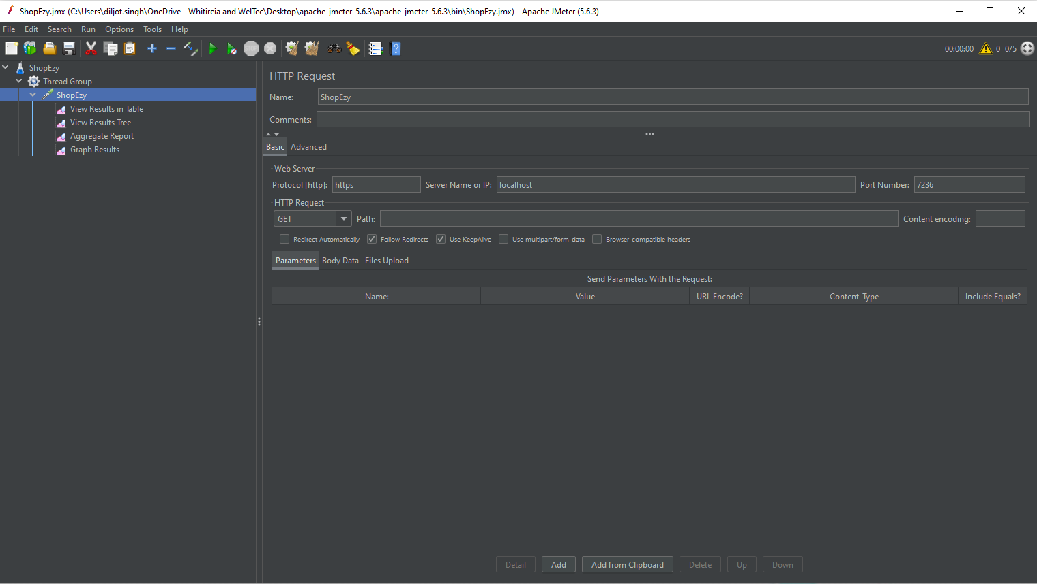
Figure 3
This picture is a screen grab of the Apache JMeter program showing the "HTTP Request" setup options for the "ShopEzy" test plan. The primary area displays the request configuration panel. The request is labelled "ShopEzy," and the remark area is blank.
The connection details are defined in the "Web Server" section:
- The protocol is configured to use "HTTP."
- The "Server Name or IP" is configured to point to "localhost."
- It is configured with port number "7218."
The method chosen in the "HTTP Request" section is "GET," and there are several options available, including:
- (checked) "Follow Redirects"
- "Use Keepalive" (selected)
- "Use multipart/form-data" and "Browser-compatible headers," which are not selected.
Although there are more choices for adding parameters, body data, or file uploads, nothing is added to these fields now. Additionally, there are choices to "Send Parameters with the Request" at the bottom; however, there is nothing in the parameter entry table.
The "ShopEzy" thread group has been enlarged to display reporting elements such as "View Results in Table," "View Results in Tree," and "Aggregate Report." The left pane displays the same test plan structure as earlier photos. The test can be saved, started, or stopped using the toolbar at the top, and the status bar indicates that it has been running for 17 seconds. The warning indicators shown at the top-right corner indicate potential problems with performance or settings. The comprehensive configuration is shown in this screenshot. setting up JMeter to send web requests in the context of an HTTP request during performance testing.
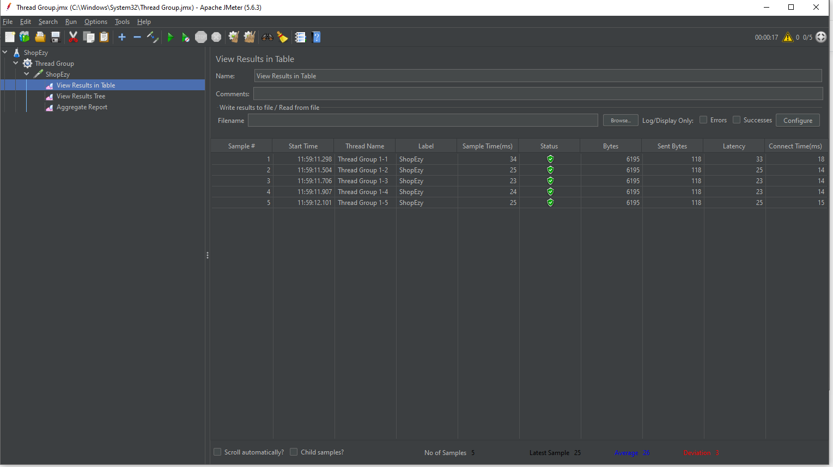Figure 4
The picture shows a screenshot of the performance testing tool Apache JMeter, with results explicitly displayed in the test plan's "View Results in Table" section. The test plan hierarchy is shown in the left panel. It has components like "View Results in Table" and "Aggregate Report" within a "Thread Group" called "Shopify."
Comprehensive data regarding test samples are displayed in tabular form on the main panel. Some of the fields in the table are "Sample #," "Start Time," "Thread Name," "Label," "Sample Time (ms)," "Status," "Bytes," "Sent Bytes," "Latency," and "Connect Time (ms)." A sample that was run during the performance test is represented by each row. For instance, "Thread Group 1-1" is responsible for executing the first sample, which has a start time of 11:50:18.224, a "Sample Time" of 23 milliseconds, and a successful status (shown by the green indicator). Additional metrics including bytes sent/received, latency, and connection time are displayed in the last columns.
The interface displays important reaction metrics for analysis, and the test results aid in assessing how well the system is doing under test.

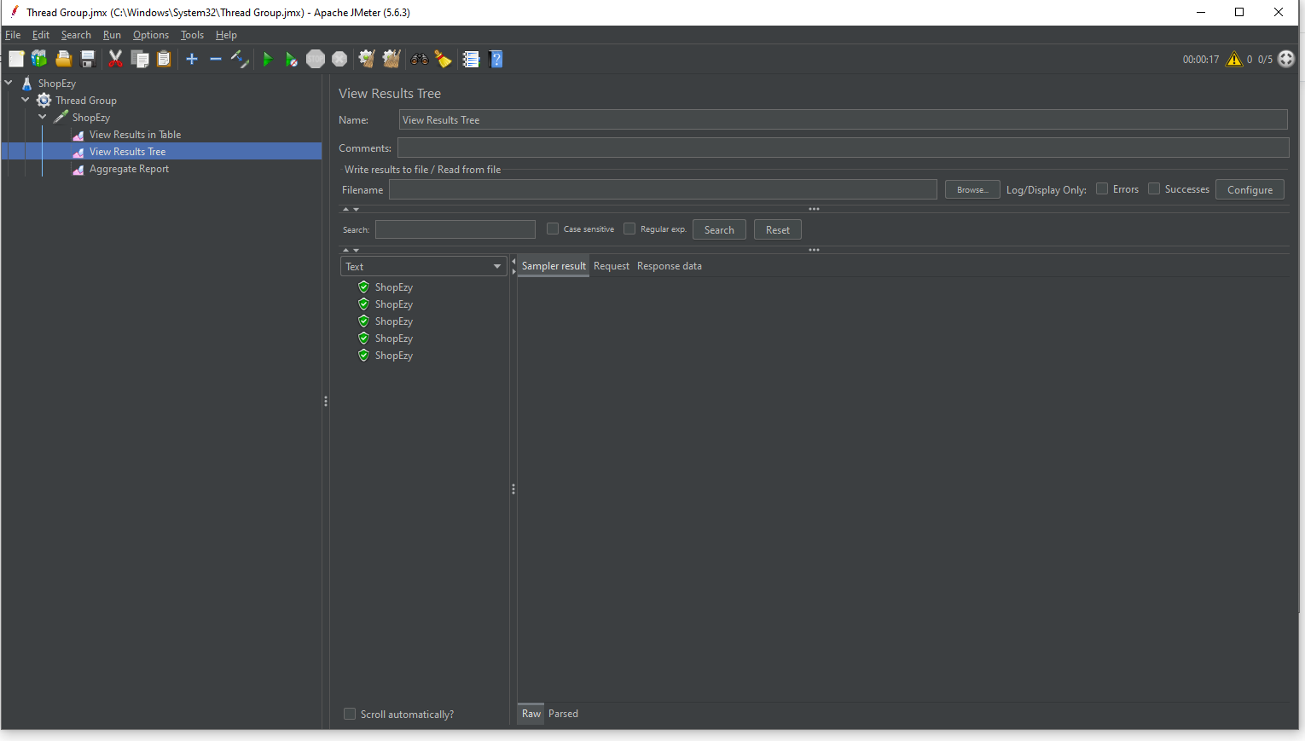
Figure 5
Another screen grab of Apache JMeter, this one focuses on the "View Results Tree" component of the test plan called "Shopify." The test plan structure is displayed in the left panel, where you can see a "Thread Group" and choices like "View Results in Table" and "Aggregate Report." After choosing the "View Results Tree" tab in the main panel, a thorough, hierarchical view of each test result is displayed.
Under the "Sampler result" tab in the main area, a list of sample results is displayed on the left. Every item has the designation "Shopify," signifying distinct test transactions included in the performance evaluation. Each test's successful status is shown in the list of samples by green checkmark icons.
Additional details, such "Request" and "Response data," can be viewed on the right; however, in this screenshot, these elements are not extended. Drilling down into specific transaction details is possible using the tabs labeled "Sampler result," "Request," and "Response data" located at the bottom of the screen.
In order to troubleshoot and validate test requests and responses during performance testing, this view is utilized.

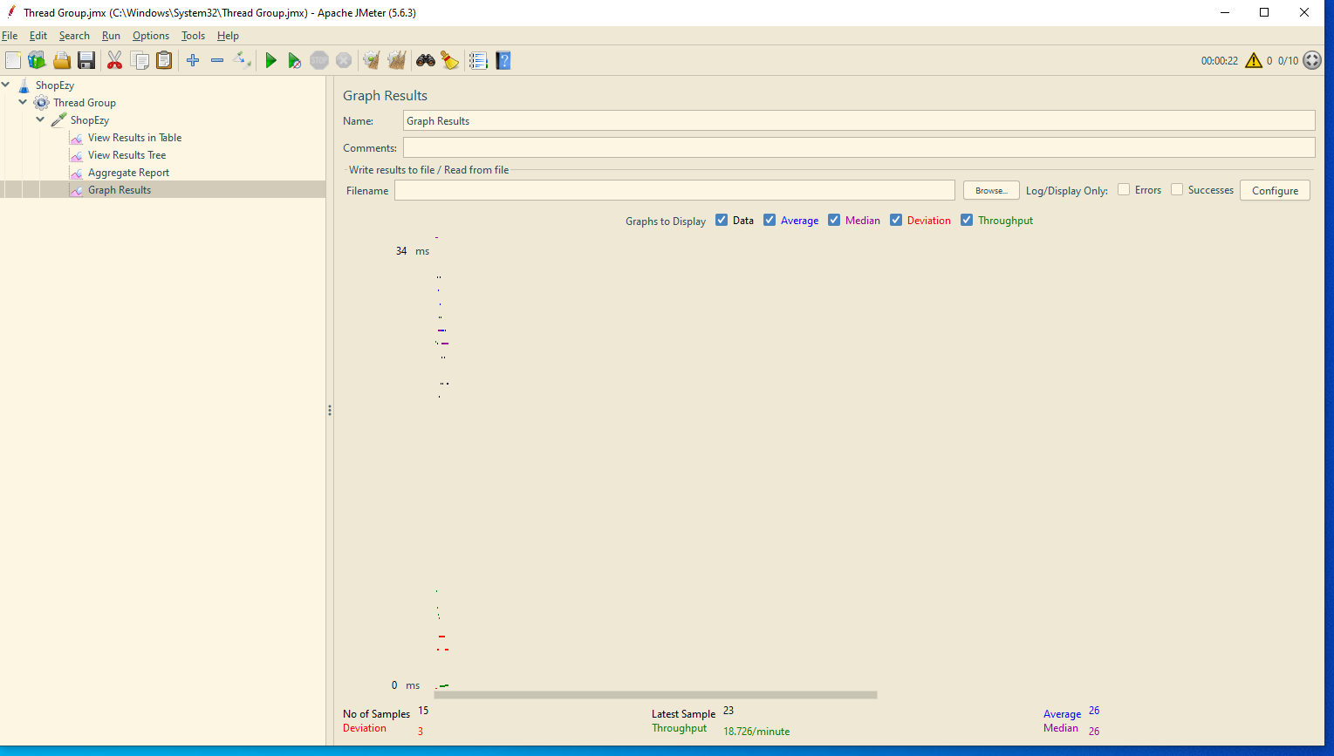
Figure 6
This image displays Apache JMeter's "Graph Results" area, specifically for the "Shopify" test plan. The test plan hierarchy is shown in the left panel and consists of elements such as "View Results in Table," "View Results Tree," "Aggregate Report," and "Graph Results." Right now, the "Graph Results" option is chosen.
A graphical depiction of the performance test results is displayed on the main screen. The x-axis shows the order of test samples, and the y-axis the response time in milliseconds. Though no precise graph lines are visible in this specific capture, the graph appears essentially blank with only a few scattered data points and colored markers showing various performance measures, such as Data, Average, Median, Deviation, and Throughput.
At the bottom of the interface, summary statistics are provided, such as:
- Number of samples: 15
- Deviation: 5 ms
- Latest sample time: 23 ms
- Throughput: 18.728 samples per minute
- Average response time: 25 ms
- Median response time: 23 ms
Throughput, reaction time, and other metrics are evaluated, and the graph and statistics highlight how response times change among samples to assist visualize the test results. When conducting load testing, this view is helpful for examining patterns in performance over time.

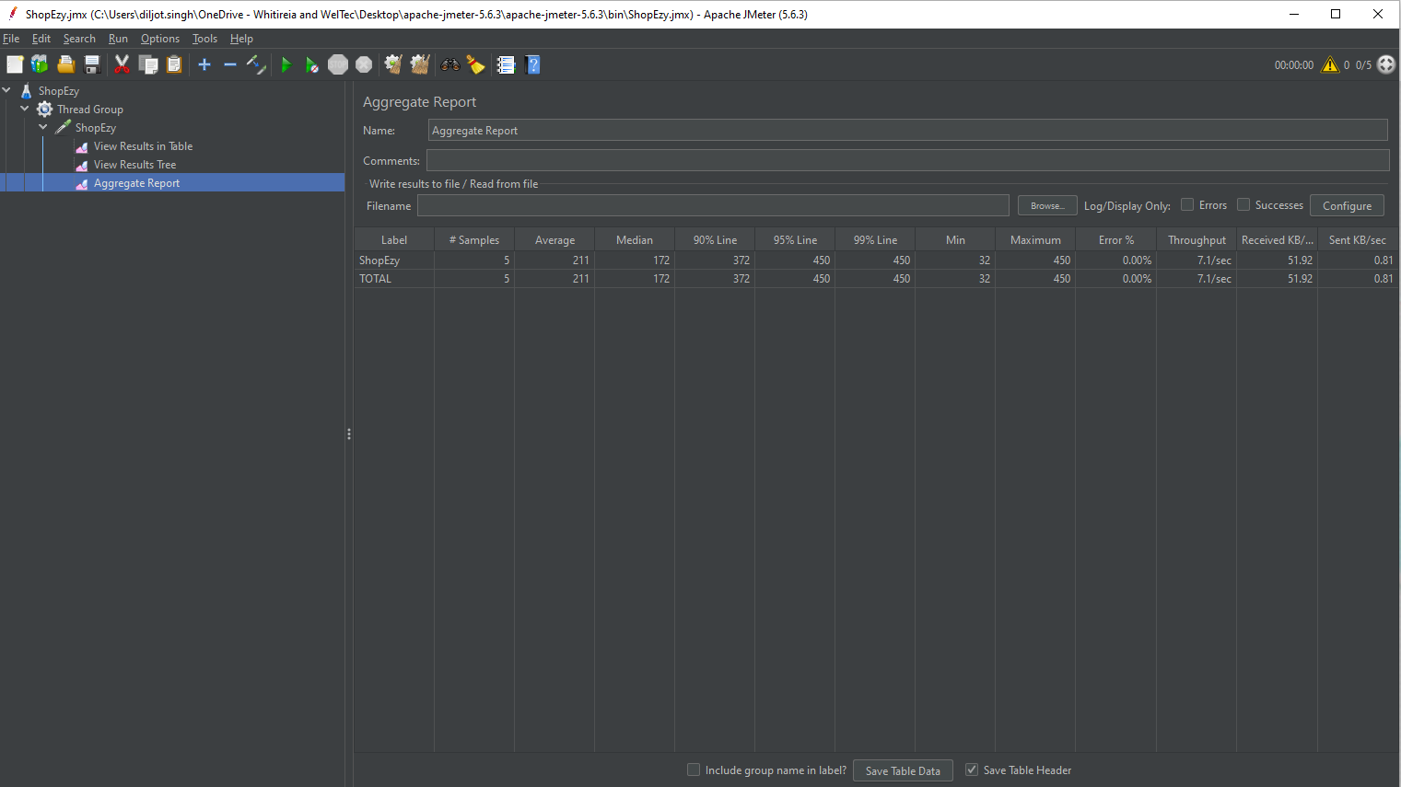
Figure 7
The picture shows the Apache JMeter "Aggregate Report" screen. It gives test summary statistics for Shopify, including the number of samples (5), average response time (20 ms), median (172 ms), 90th percentile (33 ms), maximum (450 ms), error percentage (0.00%), throughput (7.1/sec), and sent/received data rates. There aren't any mistakes.
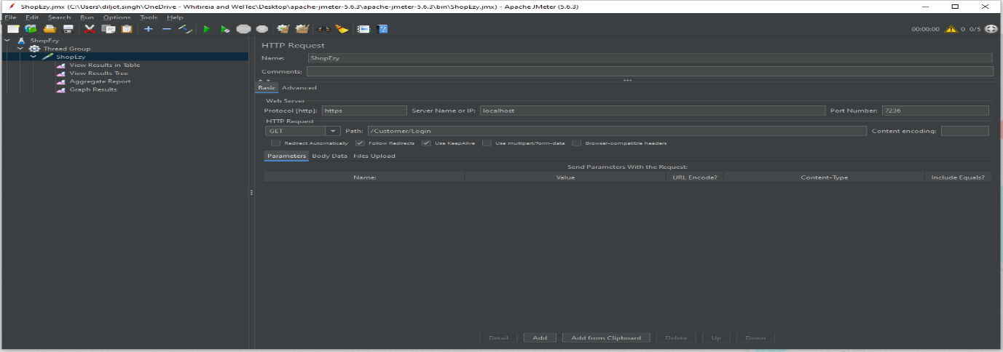
Figure 8
The image displays an HTTP Request Sampler configuration screen for an Apache JMeter interface. The "ShopEzy" test plan is located within a Thread Group. The path "/Customer/Login" is the target of the HTTP request, which is configured to utilize the GET method and a server IP of "localhost" on port 7236. Various settings like "Redirect Automatically" and "Follow Redirects" are also available for configuration.

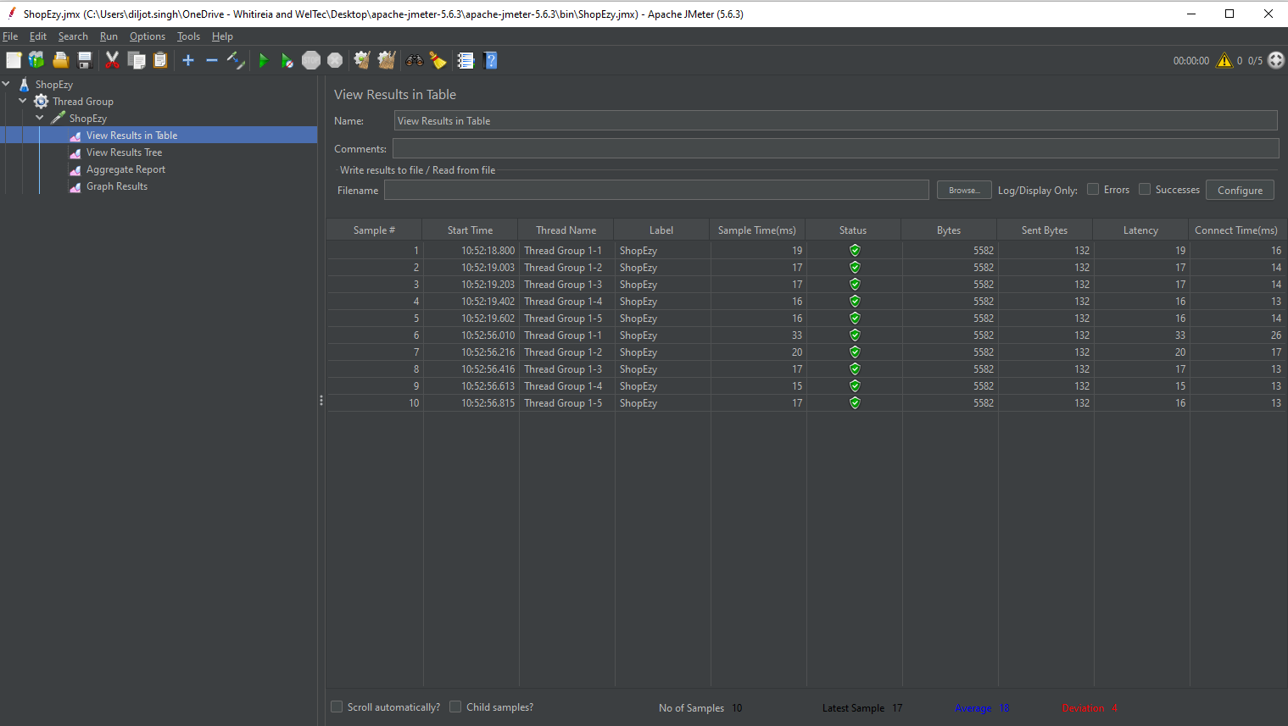
Figure 9
The performance testing tool Apache JMeter's "View Results in Table" screen is depicted in the image. With information like start time, thread name, status (green for success), bytes, latency, and sample times, it provides an example of test results for a Shopify label. There are only successes—no mistakes.

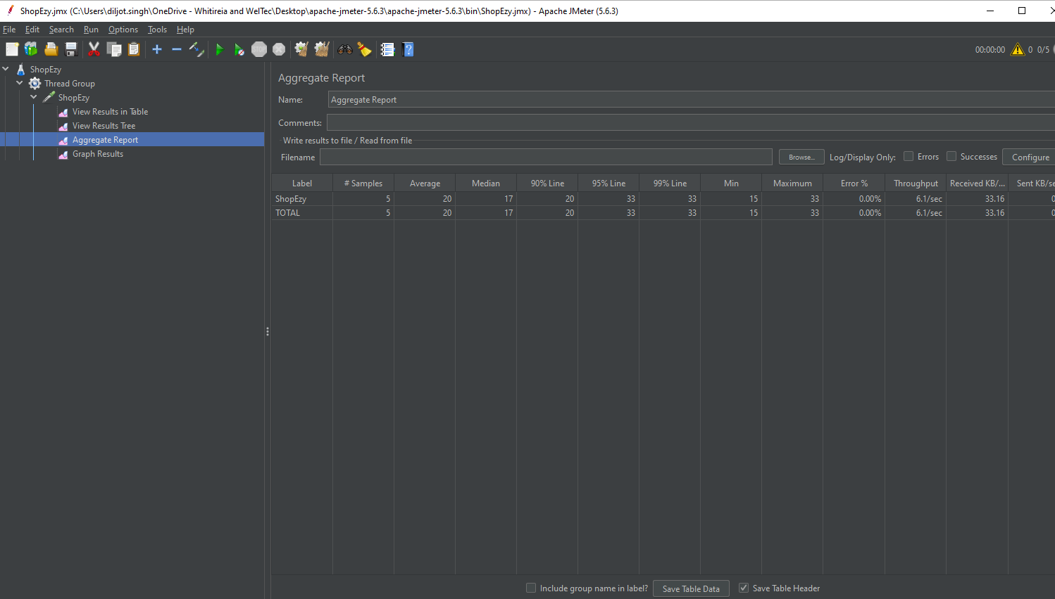
Figure 10
The picture shows the Apache JMeter "Aggregate Report" screen. It gives test summary statistics for Shopify, including the number of samples (5), average response time (20 ms), median (17 ms), 90th percentile (33 ms), maximum (33 ms), error percentage (0.00%), throughput (8.1/sec), and sent/received data rates. There aren't any mistakes.

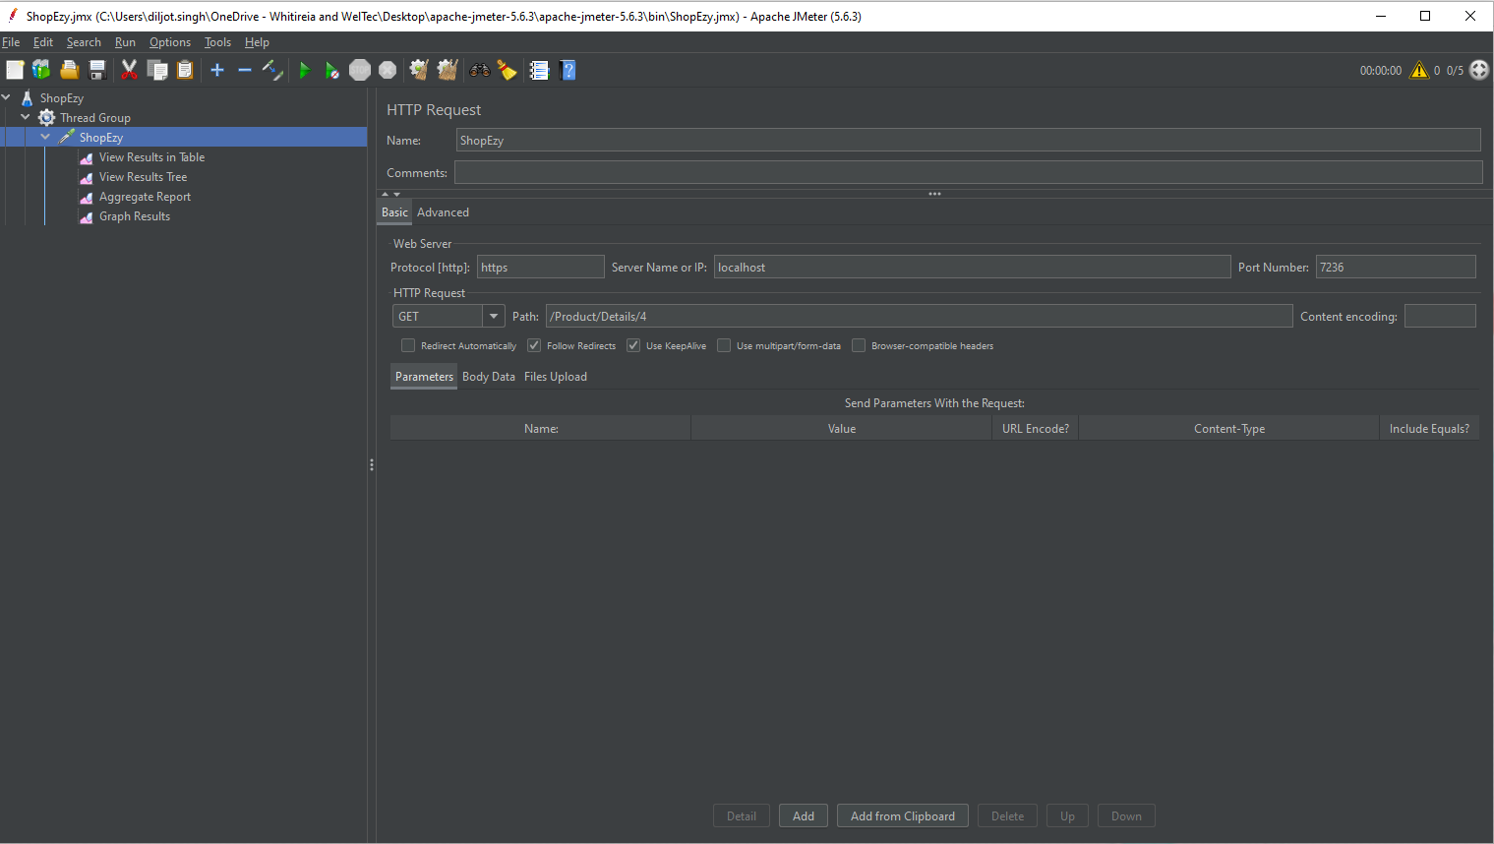
Figure 11

The screenshot shows an HTTP Request Sampler UI akin to that of Apache JMeter with the test plan "ShopEzy" in a Thread Group. Targeting the path "/Products/Details" on server "localhost" with port 7236, the HTTP method is configured to GET. To fine-tune the request, there are several choices like "Redirect Automatically," "Follow Redirects," and "Browser-compatible headers".

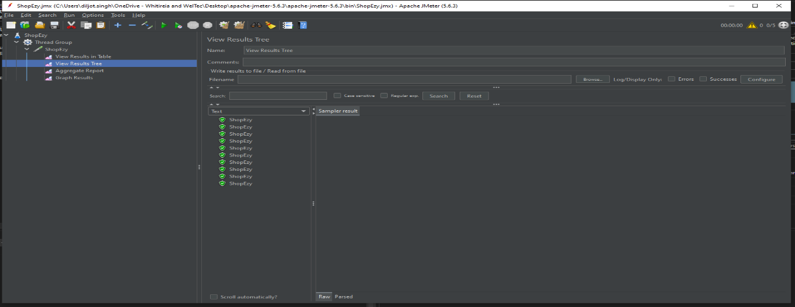
Figure 12
The performance testing tool Apache JMeter's "View Results in Table" screen is depicted in the image. With information like start time, thread name, status (green for success), bytes, latency, and sample times, it provides an example of test results for a Shopify label. There are only successes—no mistakes.

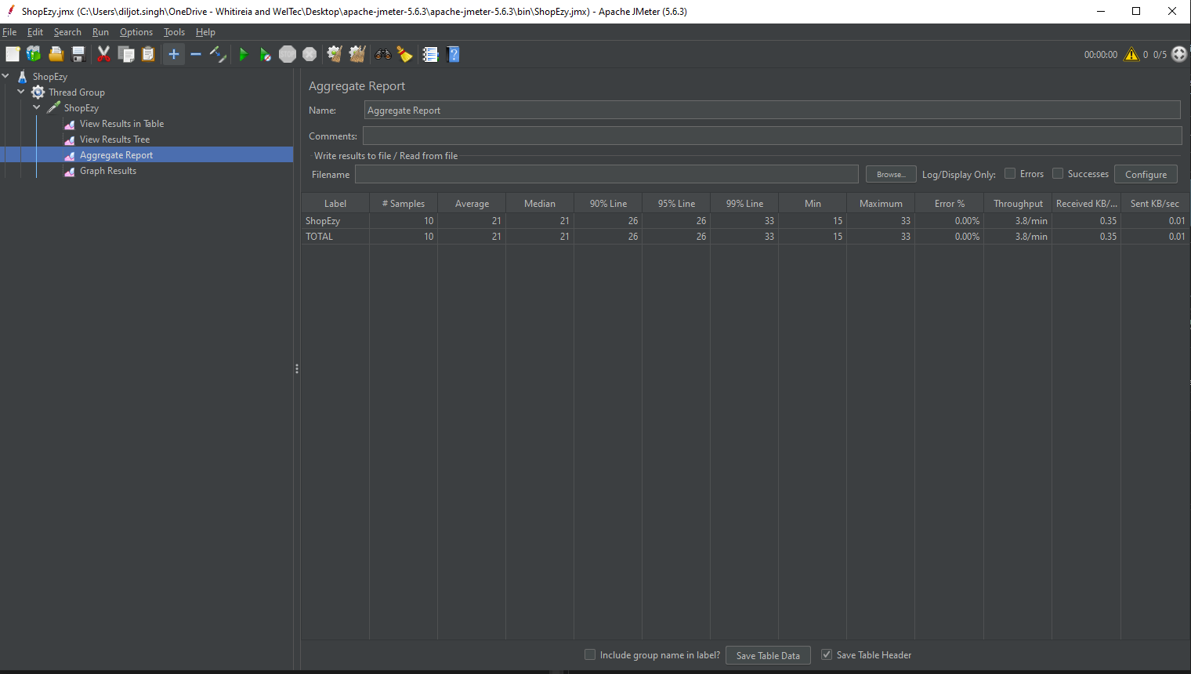
Figure 13
The picture shows the Apache JMeter "Aggregate Report" screen. It gives test summary statistics for Shopify, including the number of samples (5), average response time (20 ms), median (21 ms), 90th percentile (26 ms), maximum (33 ms), error percentage (0.00%), throughput (3.8/min), and sent/received data rates. There aren't any mistakes.

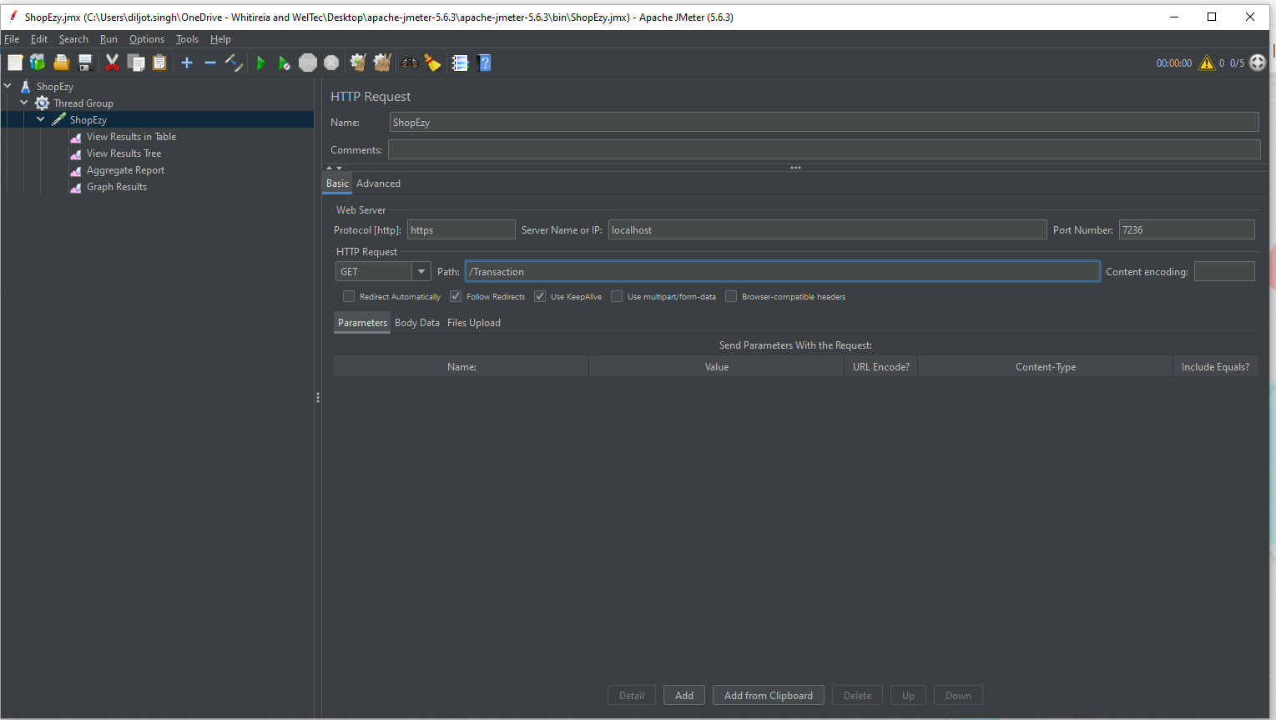
Figure 14
This picture displays an additional Apache JMeter interface within a Thread Group for the test plan "ShopEzy" that includes an HTTP Request Sampler. The server "localhost" is hosting the HTTP request on port 7236, with the path "/Transaction" and the GET method. There are other configuration choices, such as "Redirect Automatically," "Follow Redirects," "Use KeepAlive," and "Browser-compatible headers".

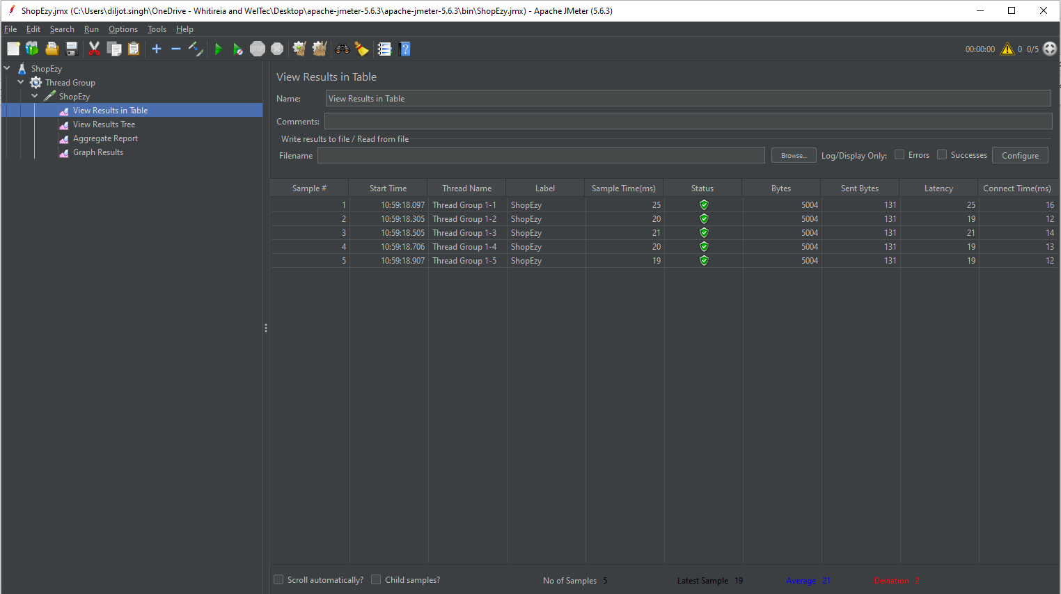
Figure 15
The image displays the output of an HTTP request performance test conducted with Apache JMeter. With information on the thread group, sample time, status (green for success), transferred bytes, sent bytes, response delay, and connection time, each row represents a sample. These metrics help measure the performance of the application under test, in this case labeled "ShopEzy."

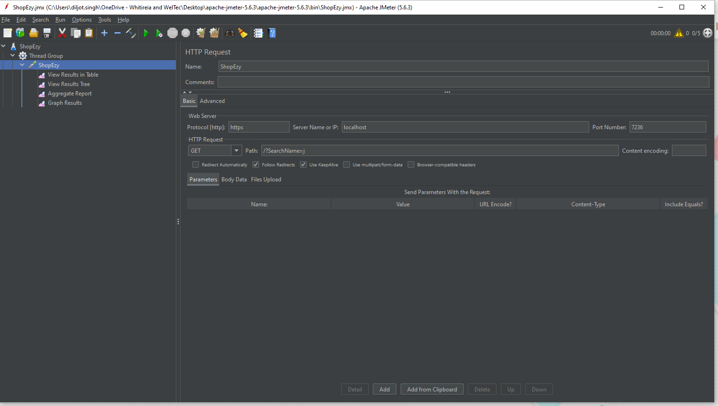
Figure 16
The image displays an HTTP Request Sampler configuration screen for an Apache JMeter interface. The "ShopEzy" test plan is located within a Thread Group. The path "/SearchNmae=j" is the target of the HTTP request, which is configured to utilize the GET method and a server IP of "localhost" on port 7236. Various settings like "Redirect Automatically" and "Follow Redirects" are also available for configuration.
The picture shows the Apache JMeter "Aggregate Report" screen. It gives test summary statistics for Shopify, including the number of samples (5), average response time (20 ms), median (20 ms), 90th percentile (21 ms), maximum (25 ms), error percentage (0.00%), throughput (6.0/sec), and sent/received data rates. There aren't any mistakes.
Figure 17

Figure 18
The image displays an HTTP Request Sampler configuration screen for an Apache JMeter interface. The "ShopEzy" test plan is located within a Thread Group. The path "/?sortOrder=Price" is the target of the HTTP request, which is configured to utilize the GET method and a server IP of "localhost" on port 7236. Various settings like "Redirect Automatically" and "Follow Redirects" are also available for configuration.

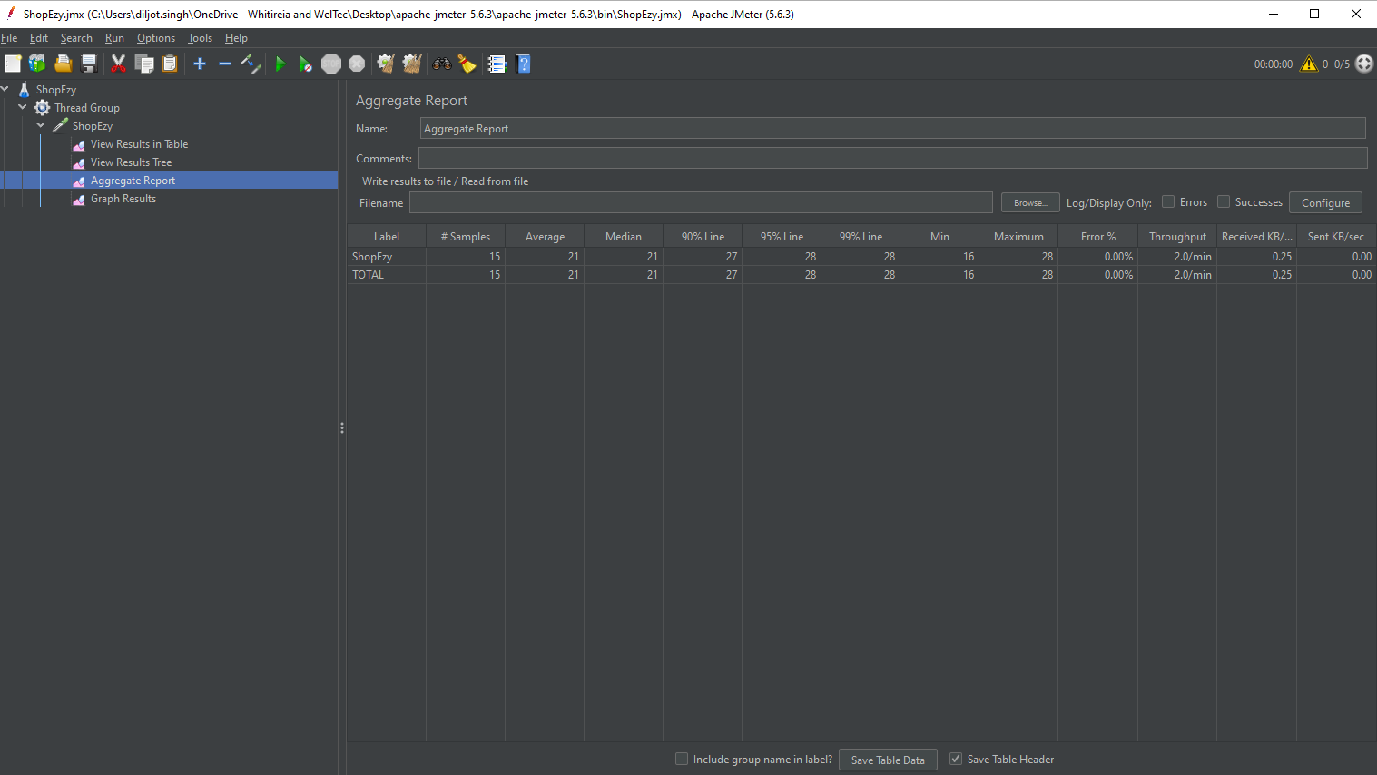
The image displays an HTTP Request Sampler configuration screen for an Apache JMeter interface. The "ShopEzy" test plan is located within a Thread Group. The path "/?sortOrder=Prices" is the target of the HTTP request, which is configured to utilize the GET method and a server IP of "localhost" on port 7236. Various settings like "Redirect Automatically" and "Follow Redirects" are also available for configuration.
Figure 19
The picture shows the Apache JMeter "Aggregate Report" screen. It gives test summary statistics for Shopify, including the number of samples (5), average response time (20 ms), median (21 ms), 90th percentile (21 ms), maximum (28 ms), error percentage (0.00%), throughput (2.0/min), and sent/received data rates. There aren't any mistakes.

Figure 20
The image displays the output of an HTTP request performance test conducted with Apache JMeter. With information on the thread group, sample time, status (green for success), transferred bytes, sent bytes, response delay, and connection time, each row represents a sample. These metrics help measure the performance of the application under test, in this case labeled "ShopEzy."

